Conceptual Design:

# User groups:

## Budget-conscious traveler:

As a budget-conscious traveler using a vacation planning application, I envision a straightforward and user-friendly experience. Upon opening the app, I'd appreciate a brief introduction explaining its purpose and features. Next, I'd set my travel budget upfront, including flights, accommodation, food, and activities. When searching for destinations, the app should display options within my budget. Once I choose a destination, an itinerary builder would be helpful, suggesting daily activities (including free or low-cost options) that I can customize. Throughout the planning process, I'd like a clear breakdown of costs (accommodation, transportation, meals). Lastly, provide local tips—hidden gems, affordable eateries, and public transport hacks—without unnecessary luxury recommendations. Simplicity, cost awareness, and practicality are my priorities! ~ Courtenay Botha 0795008677

### Bad Design Concepts:

* Like in the first image, if people input their budget once they may find it difficult to change the budget at different destinations. As a solution we might want people to input a budget for different components, like travel, food, and activities in different places.
* Like in the last two images if users only input a budget, they might have a hard time finding activities or travel plans inside their budget if it is not realistic. This limits people who only want to see some cheaper options if they don’t have a set budget yet but are trying to plan a realistic budget. We might want to filter according to their budget and suggest a bigger budget if it is not realistic or if there are too few options.

## Inspiration from AI Images:

* In the first image: I like the layout and bubbles in the firs image, all the information is very clear and not too overwhelming. The budget is very clear and always gives people an idea of their finances.
* The first image also gives the weather at that place in the background letting people know what to expect. This is a good idea and could users pick a good time to visit the destination and know what to pack.

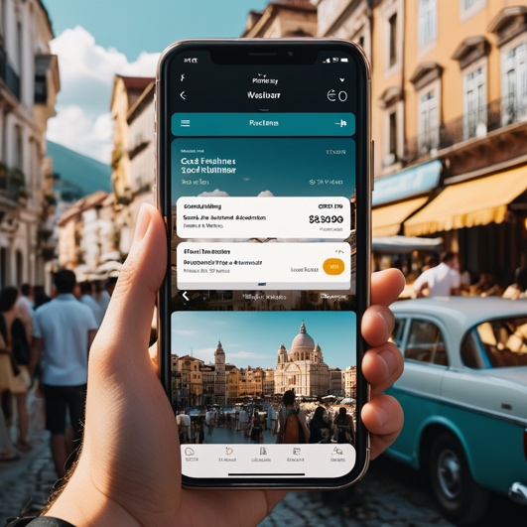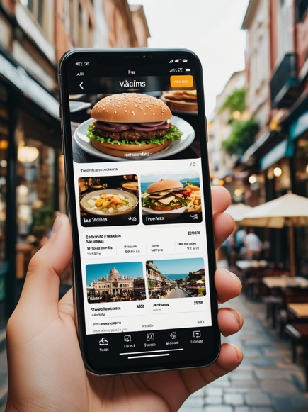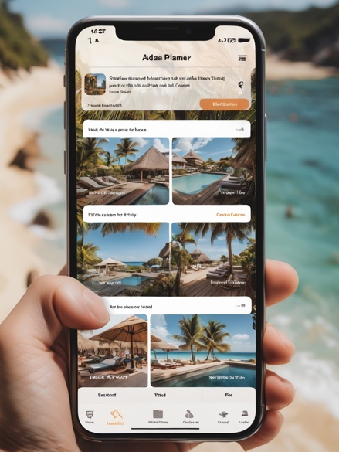

## Tourist:

For me the biggest thing about any app is that it should be very user friendly because I suck with technology!! I would love to see clear options on locations to visit followed by options on how to get there (transport etc.) and then maybe a list of activities to participate in while I am there. The flow must be in order and easy to follow. Prices must be included in every step. Pictures of accommodation and activities is a must! I would not want to read long paragraphs of descriptions but rather quick summaries or bullet points. I would like to see my preferences at the top, along with special deals and top places to travel. Along with that to be able to select destinations, categorize them and edit pre-planned trips to fit my need. I wouldn't want to see adds while browsing the app or destinations that are not to my liking. It should flow easily from choosing a destination to having a choice between creating our agenda for your trip from scratch or merely editing a pre-scheduled trip to fit to my liking. It should be easy to use and effective, straight to the point (keeping the main purpose of the app in mind).~ Leandri Erasmus 0646848694

### Bad Design Concepts:

* Having so many different options open on the page might become confusing or overwhelming to some users. Like in the firs picture, there is too much text options to read for users. We could maybe group some of the options together and only display it if clicked or hover over. We could also use descriptive icons instead of text.
* In the last image, the images are too big and could become irritating to users if they must scroll down a lot to see more content, there is also not enough text and information displayed for the locations. We could make the images smaller to fit more on the page and have text displayed over the images to give more information.

## Inspiration from AI Images:

* I like the carousel of images in the second picture, it is easy to view and works well on a mobile view. I like the choose button and the share button with clear instructions and easy to navigate design.
* I also like the size of the images in the first image, it is big enough to see the entire image, but still fits more than one image on a page.

